1PIN | I/O | function | note |  |  | Logic level | Cable designation  (sensor to Arduino)
A0
A1
A2
A3
A4
A5
A6
A7
PIN | I/O | function | Note |  |  | Logic level | Cable designation
D0 | TX | DO NOT USE: reserved for serial
D1 | RX | DO NOT USE: reserved for serial
D2 |  | DO NOT USE: PWM interferes with timer operation
D3 | O | PWM to ENB_R of L298N enable B | right motor |  |  | 3.3v not shifted | See table 1
D4 | O | PWM to ENA_L of L298N enable A | left motor |  |  | 3.3v not shifted | See table 1
D5 |  | HC-SR04 ECHO |  |  |  | 5v shifted to 3.3v
D6 |  | HC-SR04 TRIGGER |  |  |  | 5v shifted to 3.3v
D7
D8
D9
D10
D11
D12
D13
D14
D15
D16 | TX2 | TX to HMI (serial2) |  |  |  | 3.3v not shifted | Yellow wire
D17 | RX2 | RX from HMI (serial2) |  |  |  | 3.3v not shifted | Blue wire
D18 | TX1 | TX to XBee (serial1) |  |  |  | 3.3v not shifted
D19 | RX1 | RX from Xbee (serial1) |  |  |  | 3.3v not shifted
D20

PIN | I/O | function | note |  |  | Logic level | Cable designation  (sensor to Arduino)
D21
D22 | I | S1motorEncoder_L_PIN | S1 encoder signal, left motor |  |  | Shifted to 5v | MS3 (on Due)
D23 | O | IN4 of L298N | right motor |  |  | 3.3v not shifted | See table 1
D24 | I | S2motorEncoder_L_PIN | S2 encoder signal, left motor |  |  | Shifted to 5v | MS3 (on Due)
D25 | O | IN3 of L298N | right motor |  |  | 3.3v not shifted | See table 1
D26 | I | S1motorEncoder_R_PIN | S1 encoder signal, right motor |  |  | Shifted to 5v | MS3 (on Due)
D27 | O | IN2 of L298N | left motor |  |  | 3.3v not shifted | See table 1
D28 | I | S2motorEncoder_R_PIN | S2 encoder signal, right motor |  |  | Shifted to 5v | MS3 (on Due)
D29 | O | IN1 of L298N | left motor |  |  | 3.3v not shifted | See table 1
D30
D31
D32
D33
D34
D35
D36
D37
D38
D39
D40
D41

Level Shifter
3.3 v |  | Cable Designation | 5v |  | Cable Designation
LS A0 |  | MS2 | B0 |  | MS1
LS A1 |  | MS2 | B1 |  | MS1
LS A2 |  | MS2 | B2 |  | MS1
LS A3 |  | MS2 | B3 |  | MS1
LS A4 |  | RTC2 | B4 |  | RTC1
LS A5 |  | RTC2 | B5 |  | RTC1
LS A6 |  |  | B6
LS A7 |  |  | B7

PIN | I/O | function | note |  |  | Logic level | Cable designation  (sensor to Arduino)
D42
D43
D44
D45
D46
D47
D48 | O | CS for SD adapter (logger) |  |  |  | ????
D49 | O | PS2X_CS 49 // chip select for PS2X receiver | Teleop mode |  |  | 3.3v not shifted
D50
D51
D52 | O | LED (green) – system ready status
D53 | O | LED (yellow) – alert condition |  |  |  |  | Direct from pin
D74 | SPI1 bus | SPI_MISO on ICSP connector near SAM3X8E chip | Teleop mode |  |  | n. a. | Refer to Illustration 3 and 4
D75 | SPI1 bus | SPI_MOSI on ICSP connector near SAM3X8E chip | Teleop mode |  |  | n. a. | Refer to Illustration 3 and 4
D76 | SPI1 clock | SPI_CLK on ICSP connector near SAM3X8E chip | Teleop mode |  |  | n. a. | Refer to Illustration 3 and 4
SCL1 | I2C 1 | Serial clock 1 | RTC |  |  | Shifted to 3.3v | RTC3 where is this?
SDA1 | I2C 1 | Serial data 1 | RTC |  |  | Shifted to 3.3v | RTC3 where is this?

Table 1 – Motor Control – connexions and cables

Note:
Refering to Illustration 2 - connexions in tabl e 1listed from left to right. Cable MCC is a flat 6-conductor terminated with RJ12 plugs at each end.
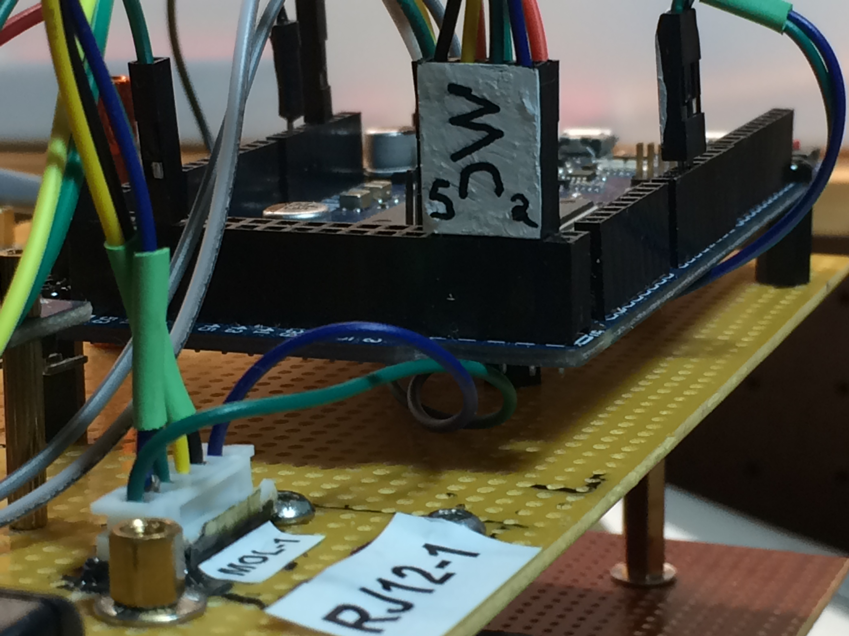Illustration 2: General view of the 2 connectors on J deck and Arduino for motor control, refer to table 1
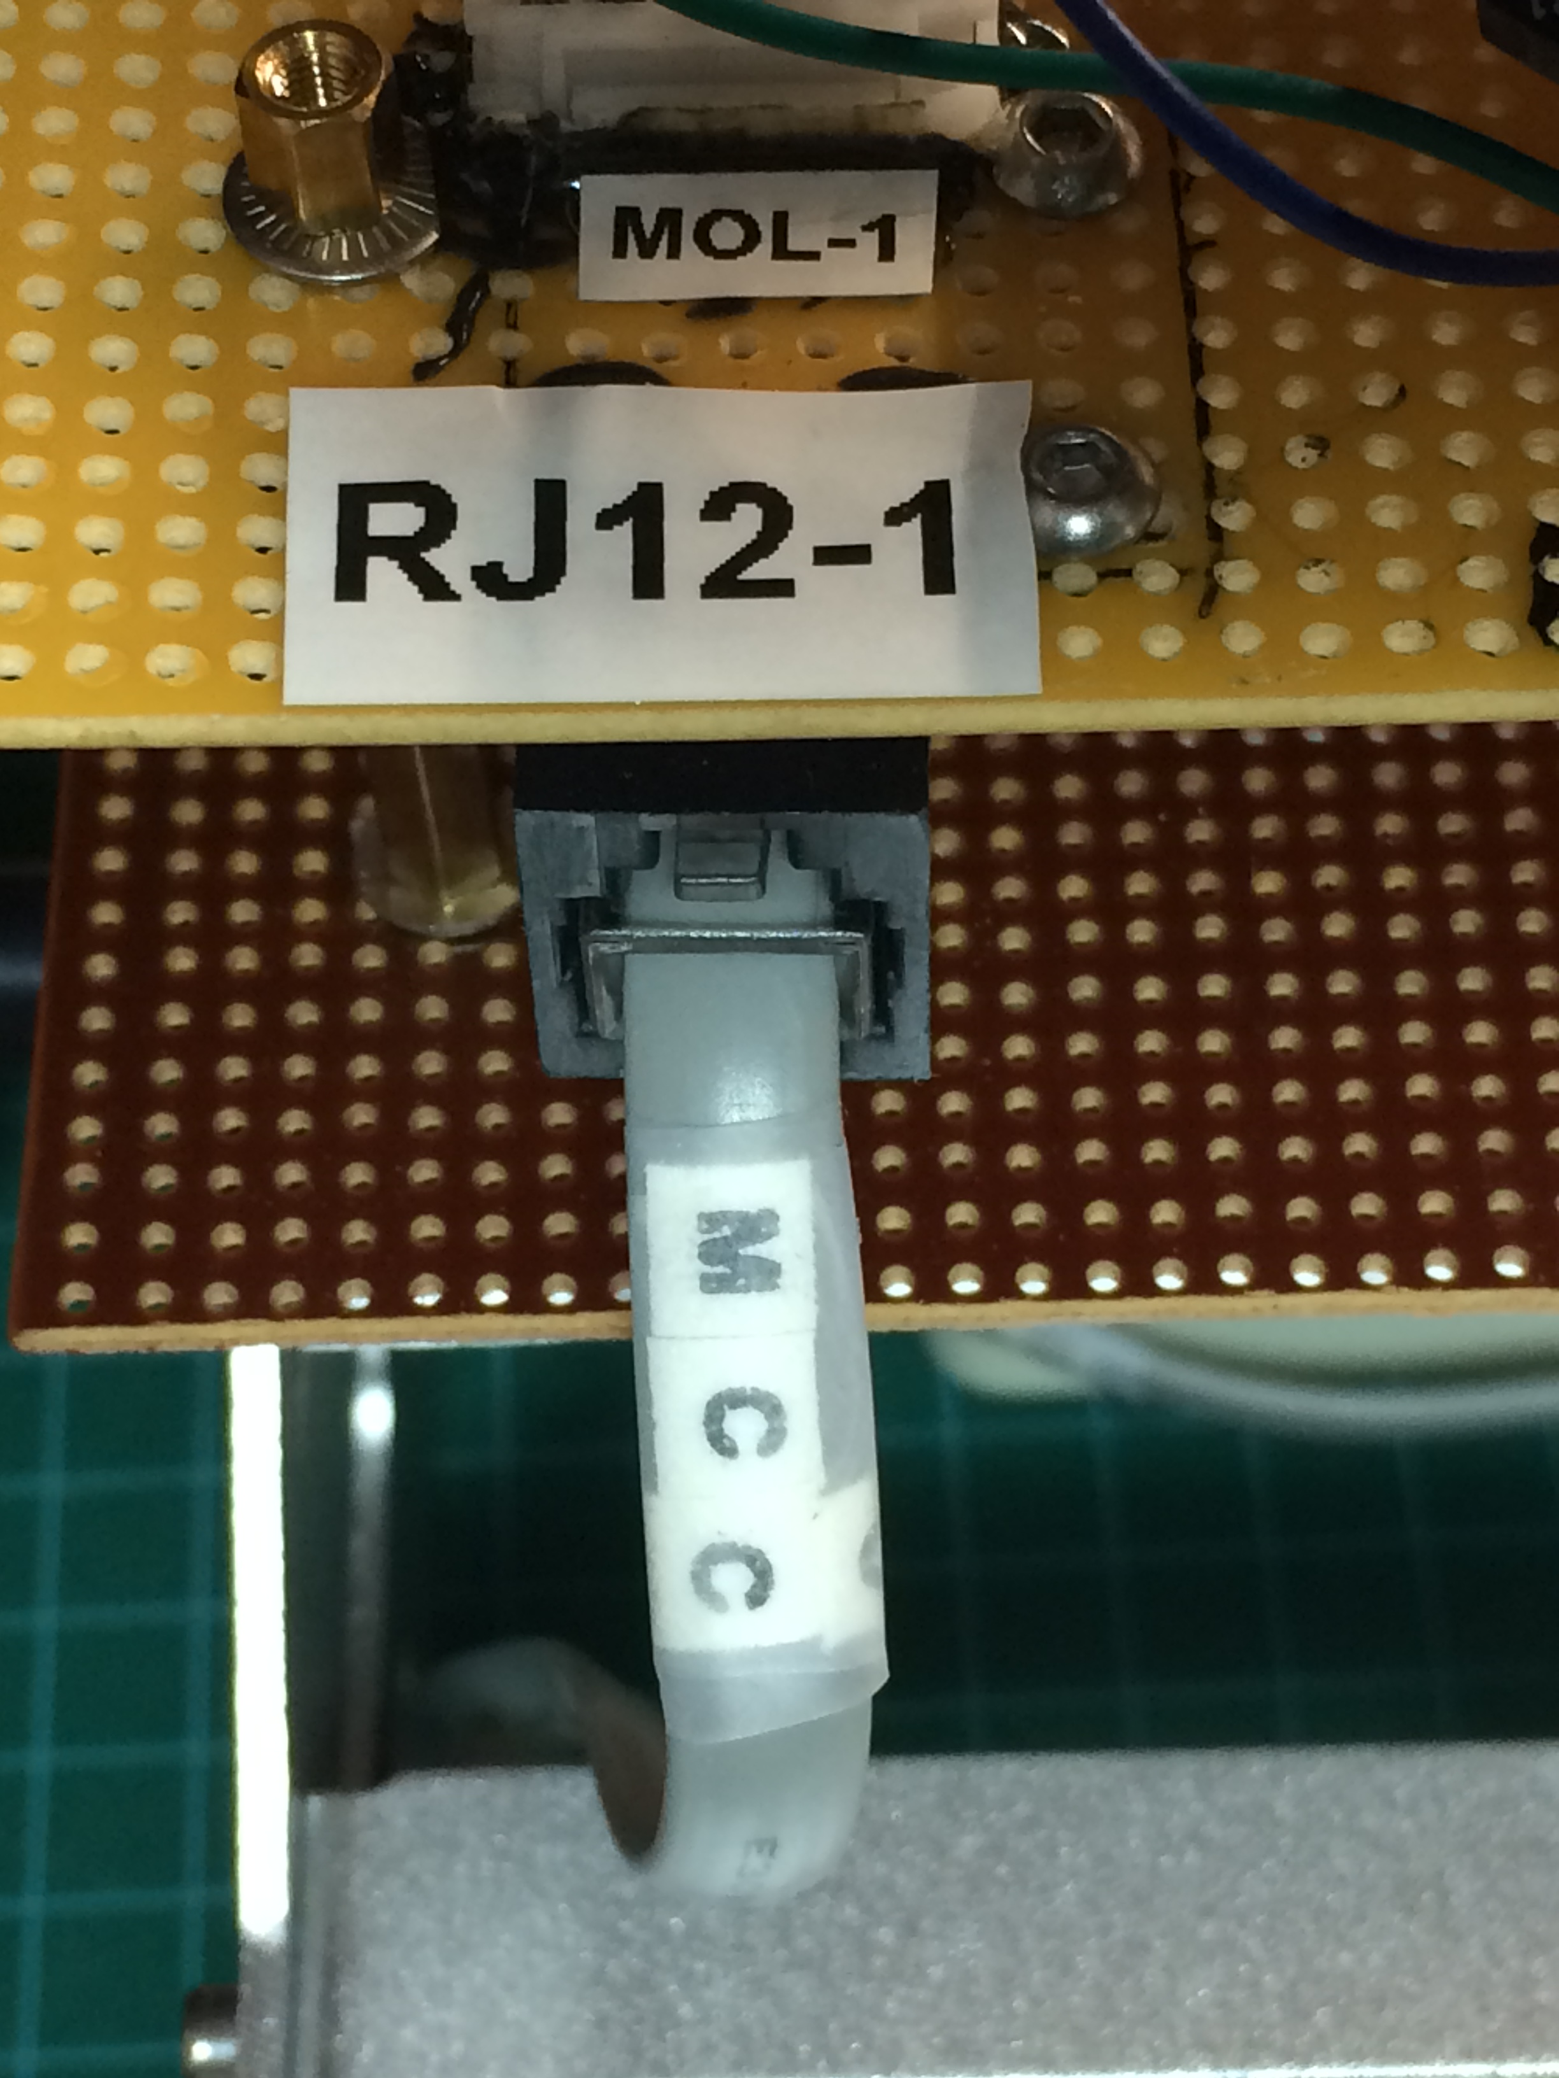Illustration 1: Detailed front view of connectors on J deck and cable for motor control, refer to table 1

Arduino pin | Connector ID on Arduino | RJ12-1 pin | MOL-1 pin
D2 | MP2 (Dupont 1x2) | 6 | 1
D23 | MC2 (Dupont 1x4) | 5 | Y
D25 | MC3 (Dupont 1x4) | 4 | G
D27 | MC4 (Dupont 1x4) | 3 | R
D29 | MC5 (Dupont 1x4) | 2 | B
D3 | MP3 (Dupont 1x2) | 1 | 2

Cable | From | To | SEE
MCC | RJ12-1 | RJ12-2 | Fig 1
LN298PWR | Power bus atop vehicule | LN298 inside L298N enclosure | Fig 5 & 6
MCC2 | RJ12-2 inside L298N enclosure | L298N inside L298N enclosure | Fig 5 & 6

TELEOP mode
PS2 controler wireless receiver

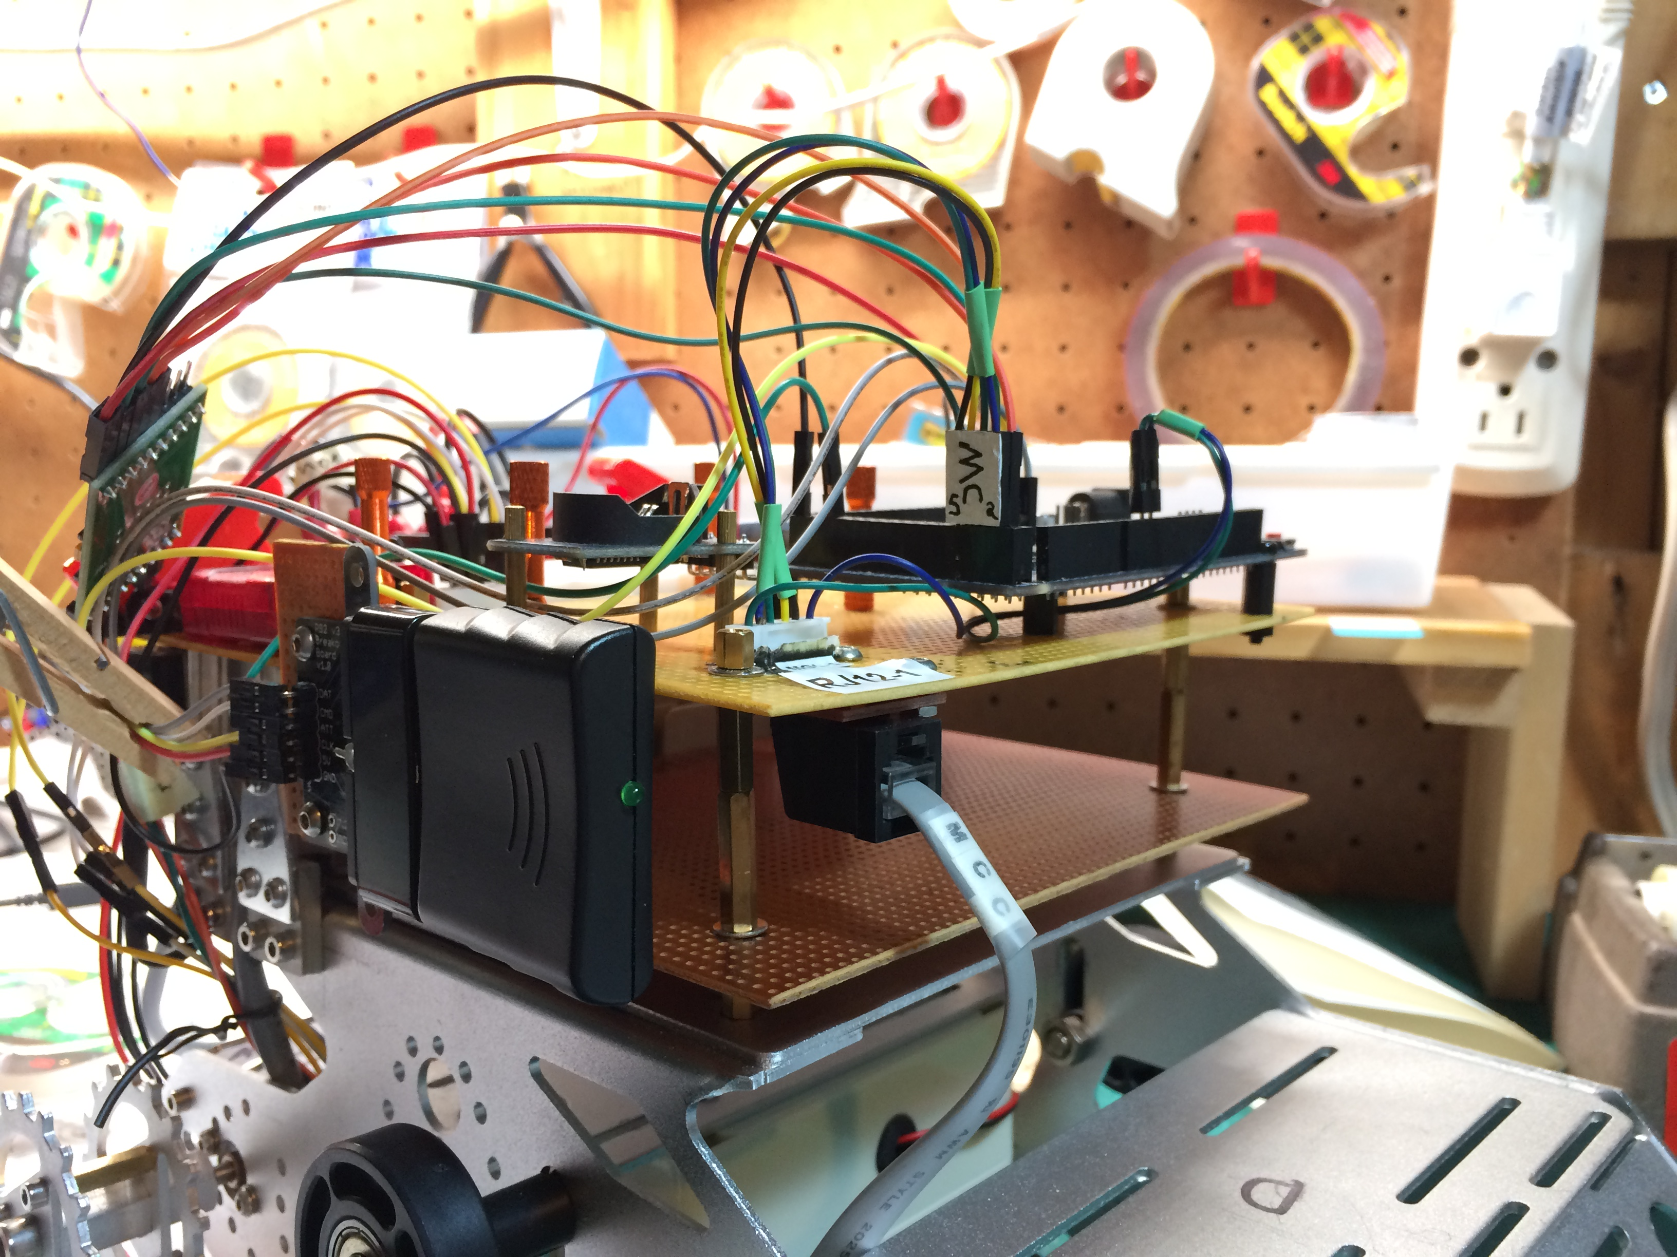Illustration 3: PS2 wireless receiver general view
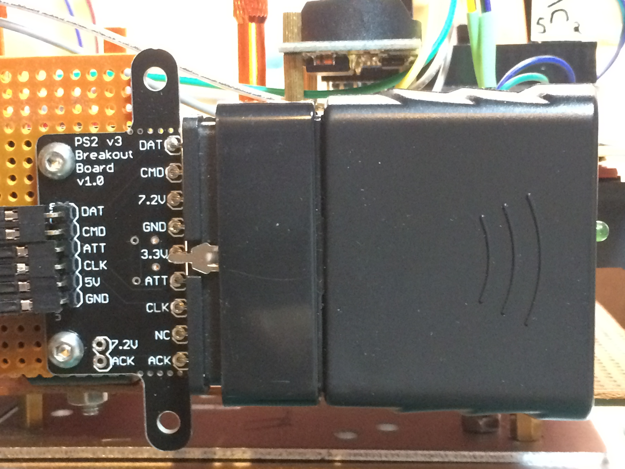Illustration 4: PS2 wireless receiver details

suite

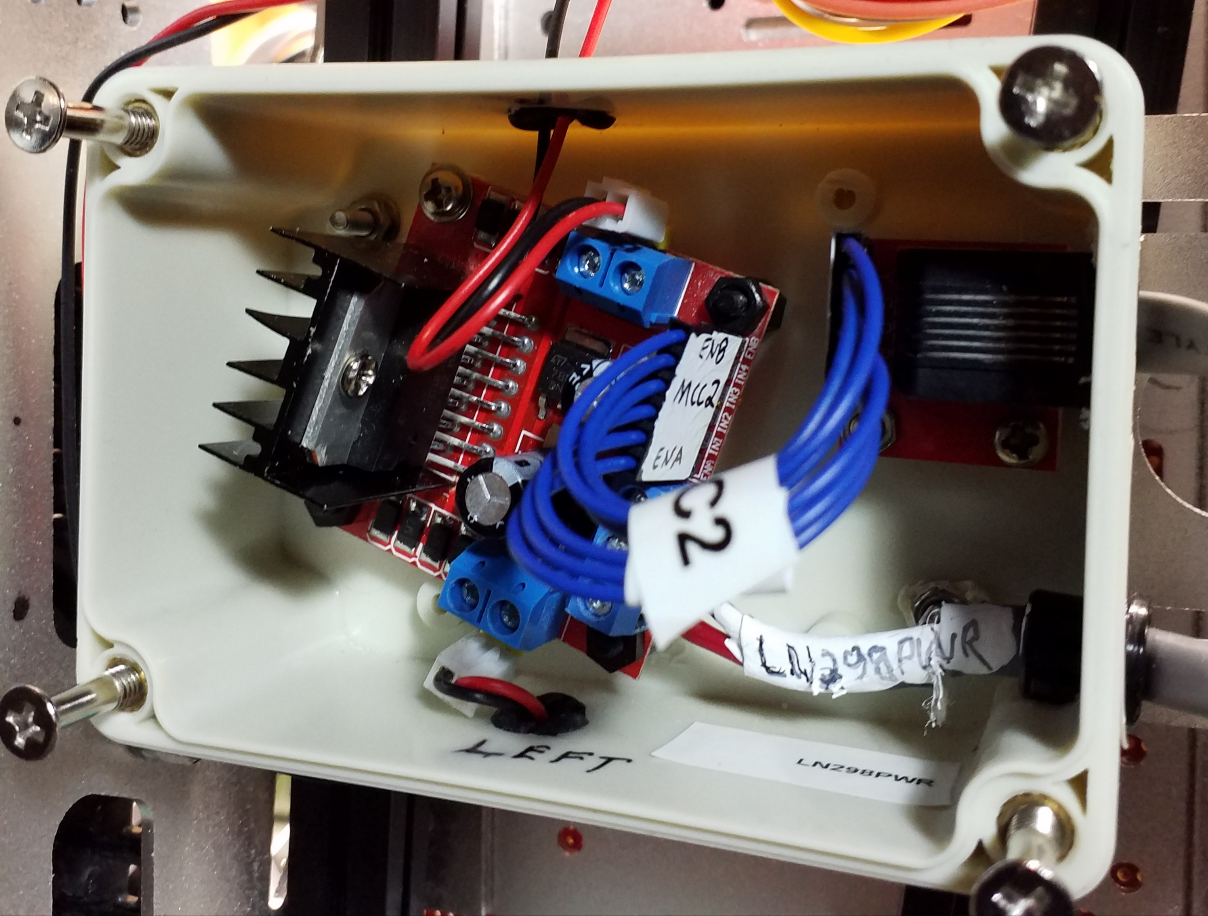Illustration 5: L298N integration inside enclosure under the vehicule showing L298N end of MCC2 cable. LN298PWR power cable is at the bottom.

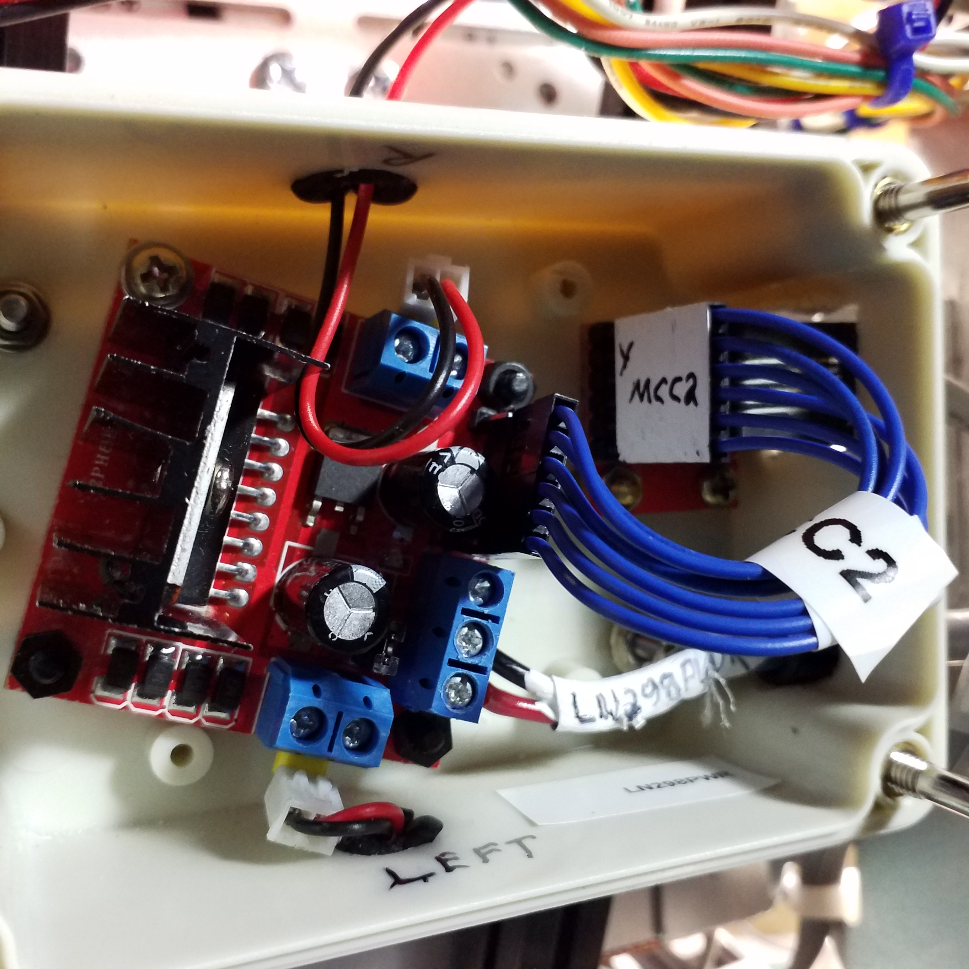Illustration 6: L298N integration inside enclosure under the vehicule showing RJ12-2 end of MCC2 cable. LN298PWR power cable is at the bottom.

